How to play:

The player will begin the game by selecting where to place their war machines.

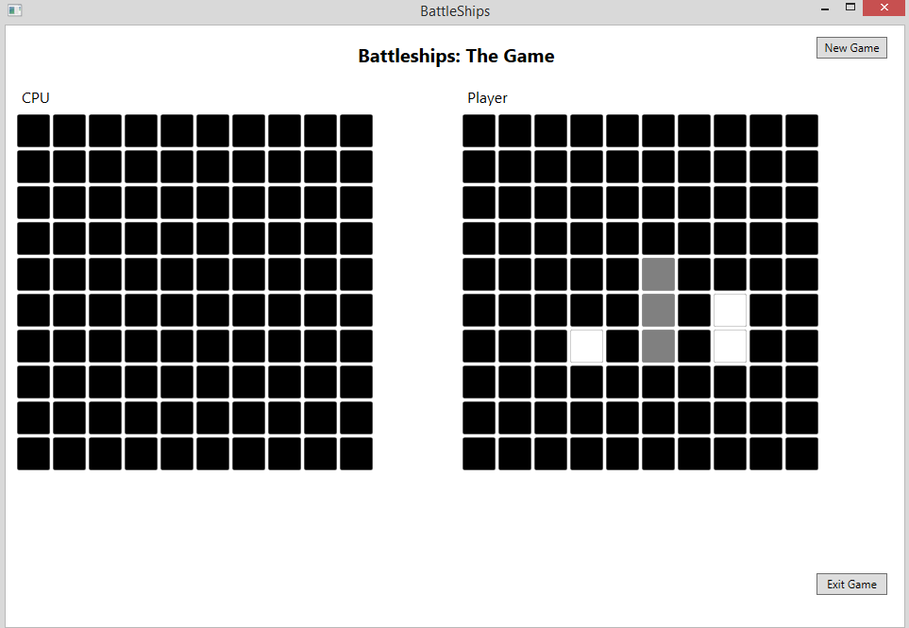

Each machine placed will need to be at least a square away from each other.

Once each machine has been placed, the game will begin. The player gets to select a square on the computer’s grid and will either miss or hit one of the CPU’s machine; vice versa for the CPU.

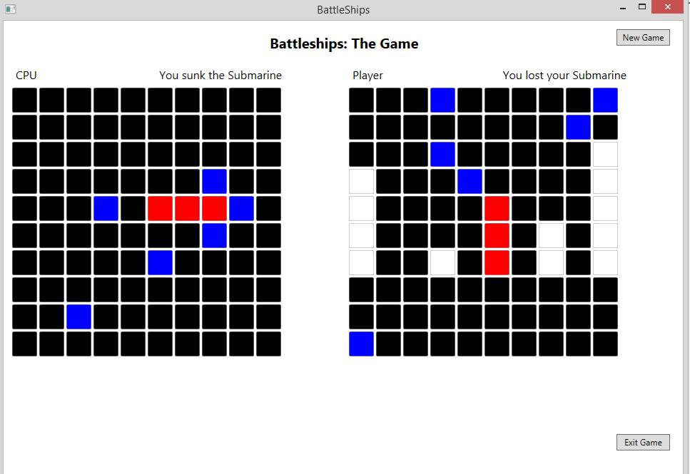

When either the player or the CPU manages to sink or destroy the opposing player’s entire machine, the game will be over and a message box will appear declaring the winner. The player can then have the choice to either start over or exit the game.

